Tableau How To Guide

When you open Tableau to the left of the screen will be a blue column displaying data types that can be imported:
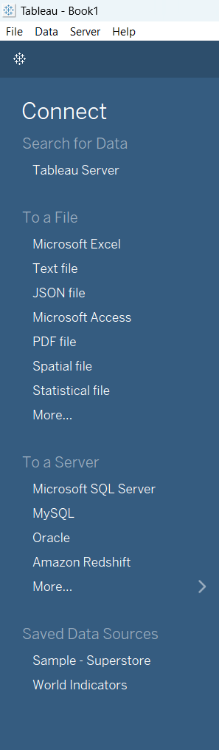
Our team uses JSON file so you’ll want to click on the JSON file option, and this will open a file explorer popup for you select the file that has all of the match JSON’s mered into a single JSON file and it will open up to a screen like this:
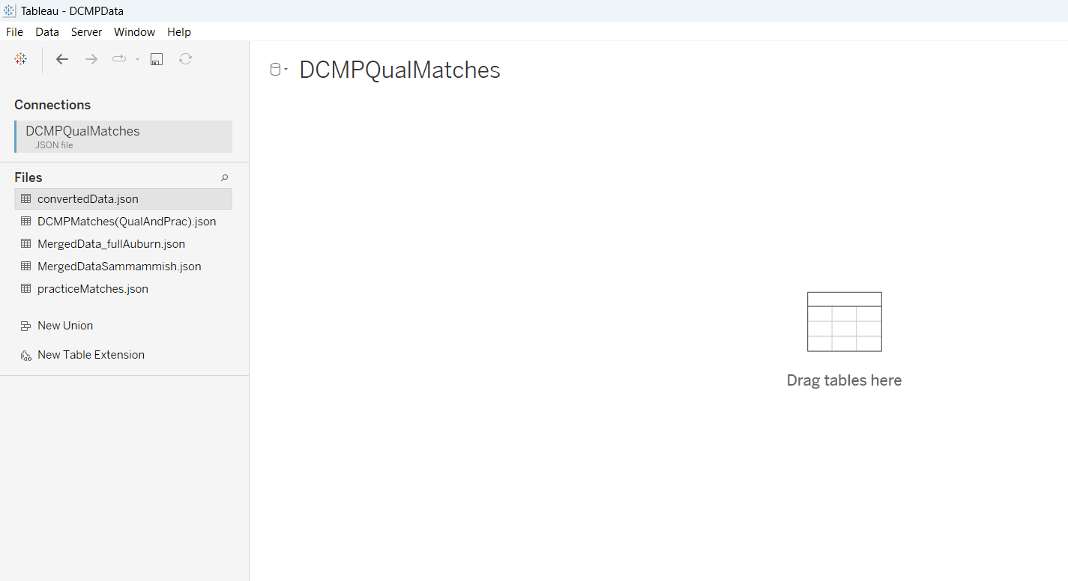
Normally there’s only going to be one file, mine just has more because of how I was using Tableau and had more than one file open at a time. Select the file you want, and drag it to the area with the text stating “Drag tables here” and then a pop up will appear like so:

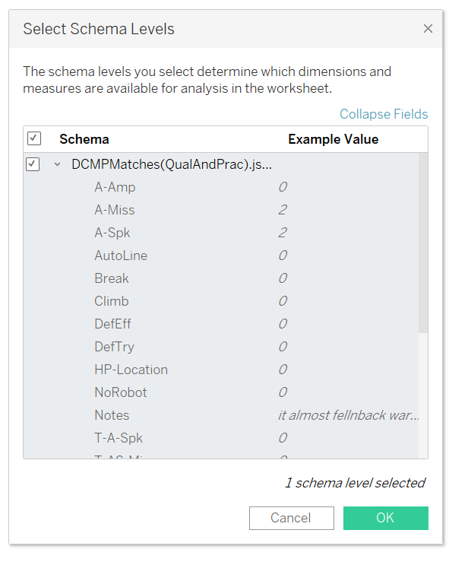
Everything here is fine, and you can just sleeve ok. Then at the bottom of the page will be a tab saying sheet 1. Click on it, and something like this will appear:
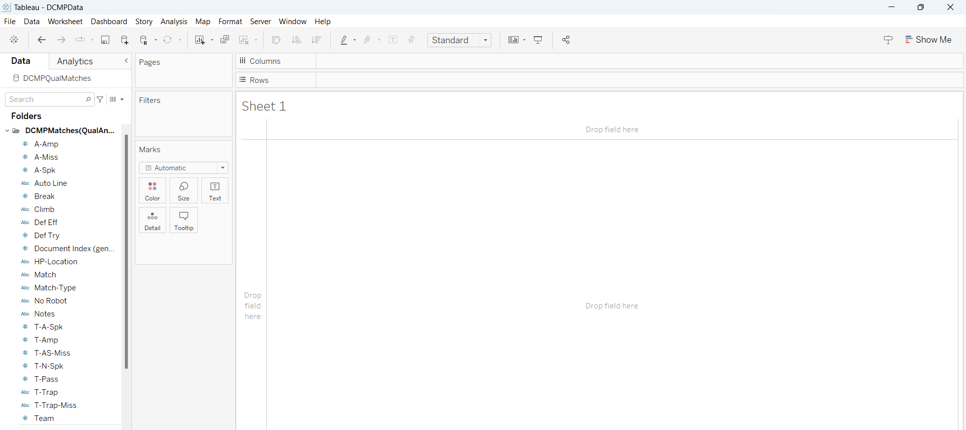
Unlike the variables on my screen(they’re on the left) the variables will appear with ‘abc’ to the left of their name signifying that they’re a string type. If you hover over a variable there’s a small downward arrow that can be clicked and from there a dropdown appears where you can select ‘change data type’ and from there select ‘whole number’.
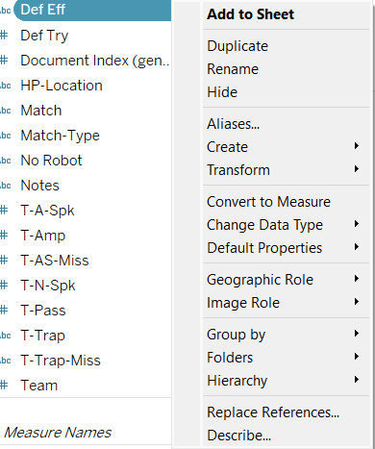
From there repeat that for all of the non-string variables until they’re all the correct data type. This is half of the work to make a graph. All of these variables are in blue, which means that they’re a dimension-type variable, but to make graphs, you need variable-type data. To create these go to the analysis at the top of the page and select “create calculated field”
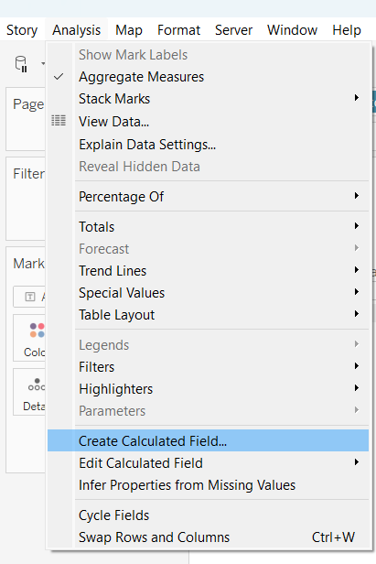
There will then be a popup to create the calculated field that asks for a name and code to fill it with what it should return. If you want the total of something just put in the name (ex: totalSpeakerAuto = speakerAuto, or if you want the same thing but with multiple variables all you need to do is add them such as totalSpeaker = speakerAuto + speakerTeleop. There are also instances when functions are needed, so here’s a mildly nonsensical example that uses them but has no practical purpose!
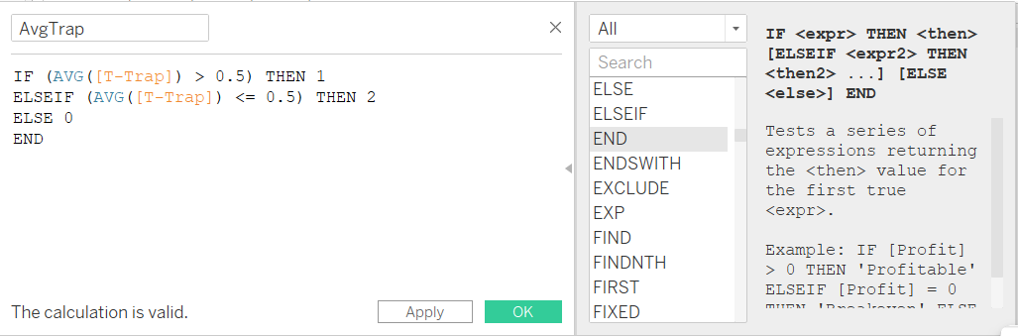
As you can see on the side it also has a list of different functions you can use if you’re not sure if something is there, as well as an explanation for them if you don’t remember the syntax or specific purpose. Another nice hint is on the bottom left corner is something that says “the calculation is valid”. If it’s not valid it’ll be in red and won’t let you ok the field. If you click on it it’ll tell you want the error is and is a great help for debugging if needed.
These calculated variables are what your graphs are going to be based around, so once you’ve created the needed calculated variables (you can always return to do more if you want!) then you’ll see on the sheet is where the graph will be, and you can drag the team number to the column or row(choose which one you prefer) and then you can’t drag your calculated variable directly to the other side of the graph, but on top of the screen are rows for variables within the column, and row and you can drag your calculated field there.
Here you can rename the sheet and get something like this:
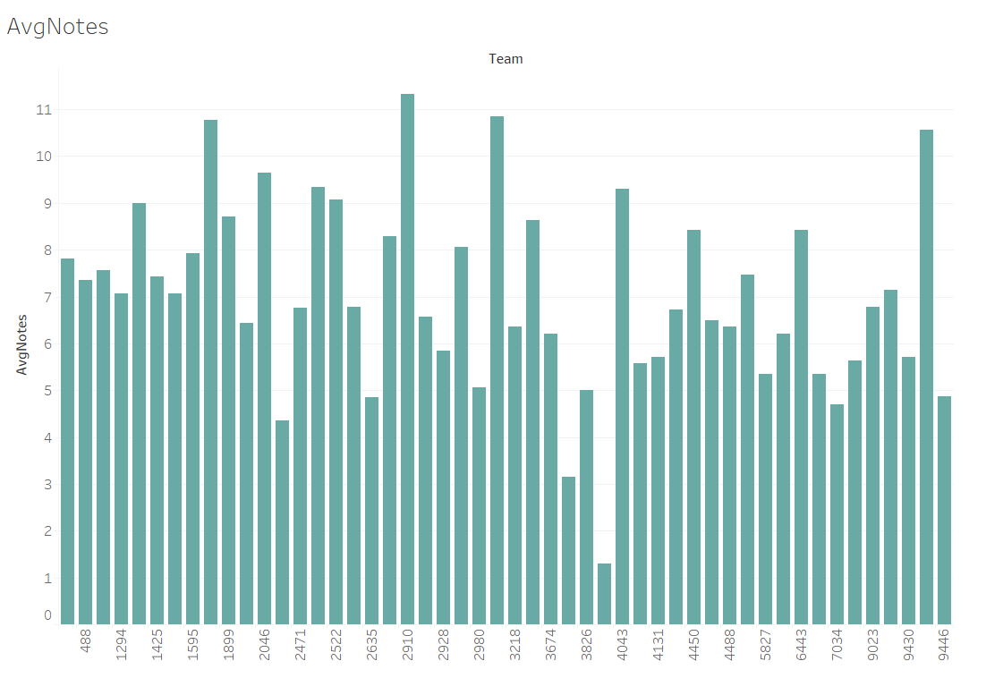
Off to the side is something that looks like this: 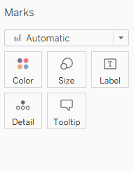 that you can click on the color button and it gives you options to change the color of the graph, or you can also add a second calculated field and get something like this: 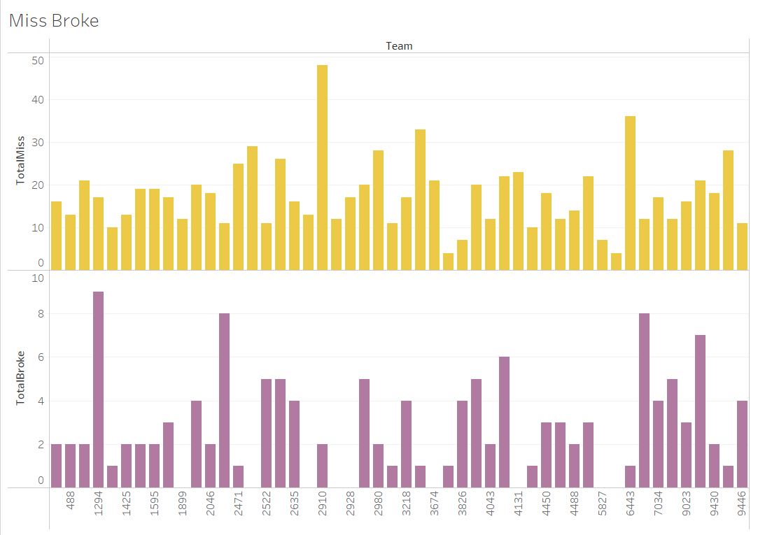 and then fro there there’s more options for how you want to structure the graph. On the top right of the page is a button that looks like this:  that you can click and see something like this : 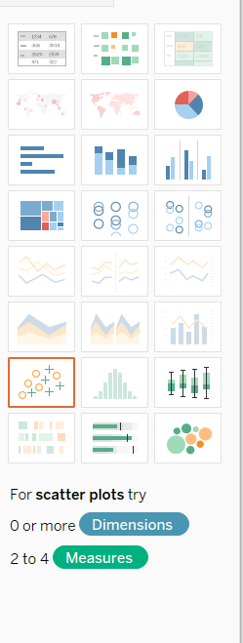
Amything that isn’t faded is a a graph that you can use, you can mess around with them to see what works best which is how graphs like this can be made :
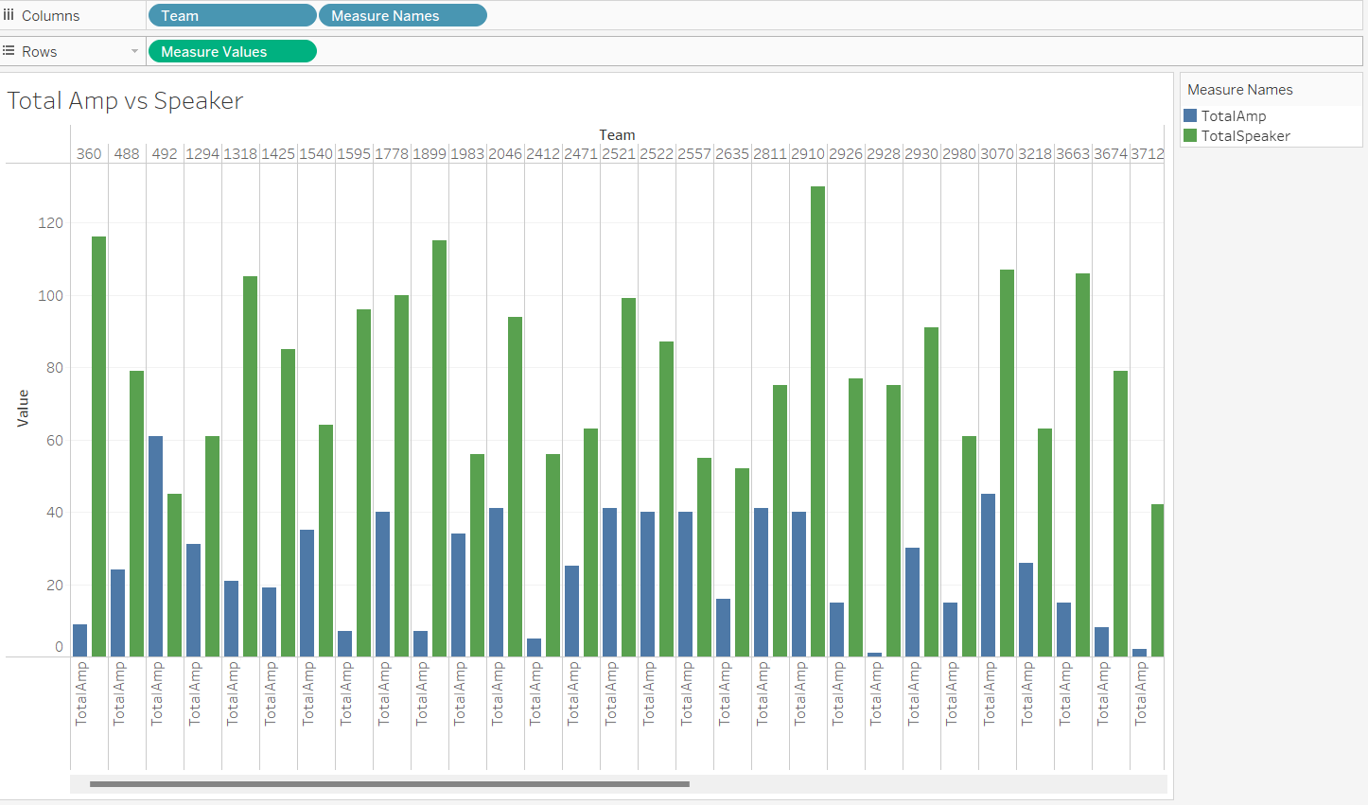

That’s the gist of it, but with this the best way to learn more is to play around, or you can also go onto tableau’s website and they also have a bunch of instructional videos.

